1. Identification Phase
Introduction
Libraries play an important role in educational institutions by providing access to books, journals, and other learning resources. However, many libraries still depend on traditional manual methods to manage book records, borrowing requests, and approvals. These manual processes can lead to inefficiencies, delays, and difficulty in tracking library activities.
The Smart Library Request Workflow in ServiceNow project aims to modernize the traditional library management process by implementing an automated workflow system. By using the ServiceNow platform, the project focuses on improving the way users request books, how librarians manage approvals, and how administrators monitor library usage.
This phase identifies the existing problems in the traditional system and defines the objectives of the proposed solution.

Problem Statement
In many institutions, the library management process involves manual record keeping or basic digital systems that do not support automated workflows. This creates several challenges for both library staff and users.
One major issue is the lack of real-time information about book availability. Students may request books that are already issued to others, and librarians must manually check records to verify availability.
Another challenge is the inefficient approval process. When a student requests a book, the request may need to be reviewed and approved by a librarian or administrator. Without automation, this process can be slow and prone to errors.
Additionally, manual systems provide limited visibility into borrowing patterns and library usage. Library administrators may find it difficult to analyze which books are most popular or how frequently books are borrowed.
Manual data entry can also result in data inconsistencies, duplication, and loss of information. Maintaining physical records or spreadsheets increases the risk of mistakes and makes reporting difficult.
Example 1
In a traditional library system, a student fills out a paper form to request a book. The librarian checks a register to confirm whether the book is available. If the book is available, the librarian manually records the borrowing details in a notebook. This process takes time and may lead to errors if the records are not updated properly.
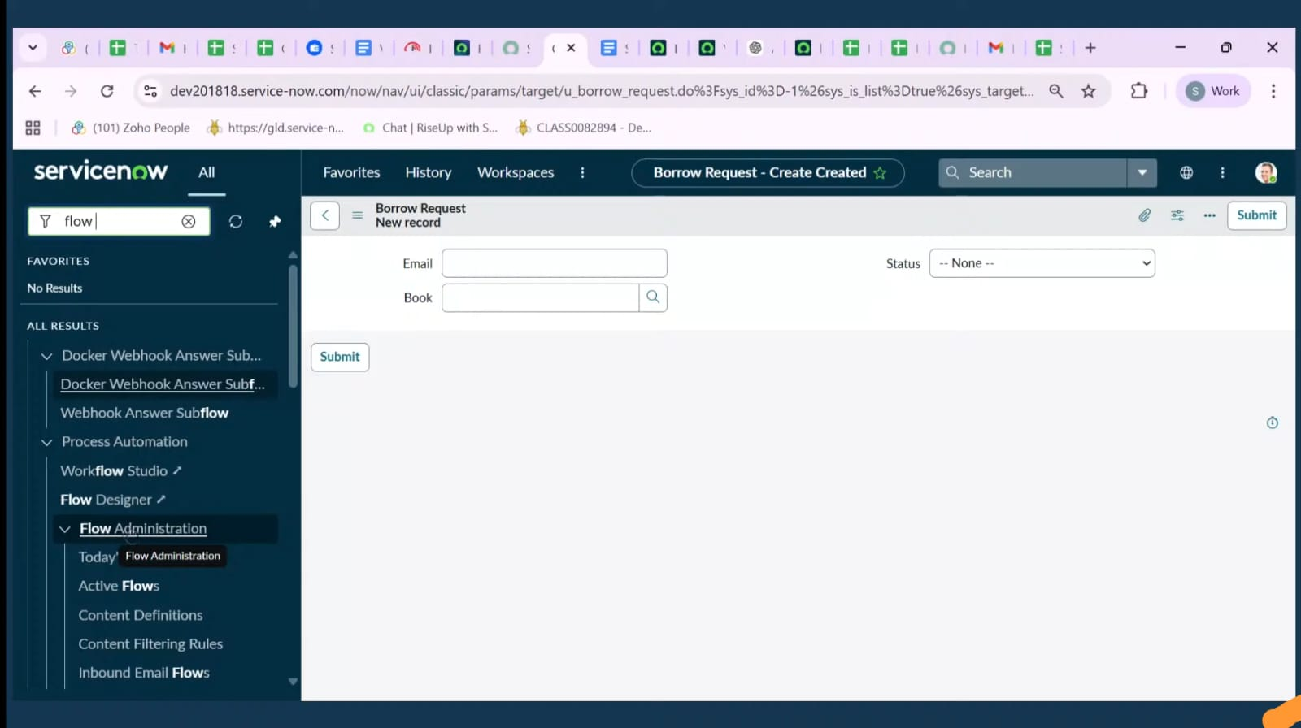
2. Requirement Analysis
Introduction
Requirement Analysis is an important phase in system development where the needs and expectations of users are identified and documented. In the Smart Library Request Workflow in ServiceNow, this phase focuses on defining the system roles, database structure, and functional capabilities required to implement an efficient library management system.
The goal of this phase is to clearly understand how the system should operate, who will use it, and what features are necessary to support library operations such as requesting books, approving requests, and managing the book catalog.

User Roles
The system is designed with role-based access control, which ensures that different users can only perform actions that match their responsibilities. The two primary roles in this system are Student and Librarian.
Student Role
Students are the main users of the library system. They can access the ServiceNow portal to search for books, check their availability, and submit borrowing requests. Students can also track the status of their requests and view their borrowing history.
Students do not have permission to modify book details or approve requests, ensuring that the system maintains proper control and security.
Example
A student named Ravi logs into the ServiceNow portal and searches for the book “Data Structures and Algorithms.” The system shows that the book is available. Ravi submits a borrow request, and the request is automatically sent to the librarian for approval.

Librarian Role
The librarian is responsible for managing the library catalog and handling borrow requests. Librarians can add new books, update book details, and track the availability of books in the system.
They also review and approve or reject borrow requests submitted by students. Once a request is approved, the librarian can issue the book and update its status in the system.
Example
A librarian receives Ravi’s borrow request in the ServiceNow workflow dashboard. The librarian checks the book’s availability and approves the request. The system then updates the book status to “Borrowed” and records the transaction in the database.

Database Tables
To store and manage information efficiently, the system uses two main database tables: the Book Table and the Borrow Request Table.
Book Table
The Book Table contains all information related to books available in the library. Each book record includes details such as the book title, author name, category, and availability status.
This table helps the system quickly determine whether a book is available, borrowed, or reserved.
Example Fields
- Book ID
- Book Title
- Author Name
- Category
- Availability Status
- 2. Requirement Analysis
- Introduction
- Requirement Analysis is an important phase in system development where the needs and expectations of users are identified and documented. In the Smart Library Request Workflow in ServiceNow, this phase focuses on defining the system roles, database structure, and functional capabilities required to implement an efficient library management system.
- The goal of this phase is to clearly understand how the system should operate, who will use it, and what features are necessary to support library operations such as requesting books, approving requests, and managing the book catalog.

- User Roles
- The system is designed with role-based access control, which ensures that different users can only perform actions that match their responsibilities. The two primary roles in this system are Student and Librarian.
- Student Role
- Students are the main users of the library system. They can access the ServiceNow portal to search for books, check their availability, and submit borrowing requests. Students can also track the status of their requests and view their borrowing history.
- Students do not have permission to modify book details or approve requests, ensuring that the system maintains proper control and security.
- Example
- A student named Ravi logs into the ServiceNow portal and searches for the book “Data Structures and Algorithms.” The system shows that the book is available. Ravi submits a borrow request, and the request is automatically sent to the librarian for approval.

- Librarian Role
- The librarian is responsible for managing the library catalog and handling borrow requests. Librarians can add new books, update book details, and track the availability of books in the system.
- They also review and approve or reject borrow requests submitted by students. Once a request is approved, the librarian can issue the book and update its status in the system.
- Example
- A librarian receives Ravi’s borrow request in the ServiceNow workflow dashboard. The librarian checks the book’s availability and approves the request. The system then updates the book status to “Borrowed” and records the transaction in the database.

- Database Tables
- To store and manage information efficiently, the system uses two main database tables: the Book Table and the Borrow Request Table.
- Book Table
- The Book Table contains all information related to books available in the library. Each book record includes details such as the book title, author name, category, and availability status.
- This table helps the system quickly determine whether a book is available, borrowed, or reserved.
- Example Fields
- Book ID
- Book Title
- Author Name
- Category
- Availability Status
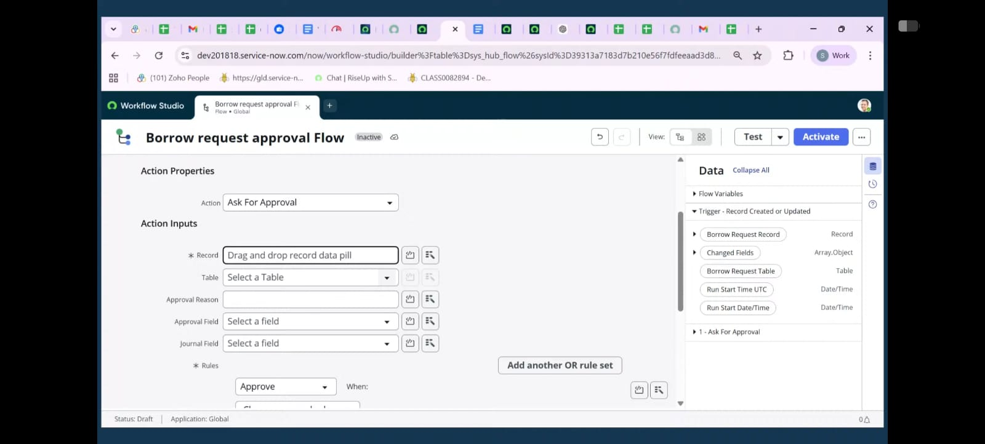
3. Project Planning Phase
Introduction
The Project Planning Phase is an essential step in the development of the Smart Library Request Workflow in ServiceNow. In this phase, the overall project structure, timeline, and implementation strategy are defined. Proper planning ensures that the system is developed in an organized and systematic manner.
This phase includes defining project milestones, identifying stakeholders involved in the project, and creating a step-by-step roadmap for the implementation process. Effective planning helps reduce risks, improves coordination among participants, and ensures that the project objectives are achieved successfully.

Project Milestones
Milestones represent the key stages in the project development process. Each milestone marks the completion of an important activity that contributes to the overall system implementation.
In this project, the major milestones include defining user roles, designing the required database tables, and creating workflows for managing borrow requests and approvals.
Role Definition
The first milestone is identifying and configuring the system roles required for the application. In the Smart Library Request Workflow, two primary roles are defined: Student and Librarian.
- The Student role allows users to search for books, request books, and track request status.
- The Librarian role allows users to manage books and approve or reject borrowing requests.
Example
When a student logs into the system, they will only see options related to searching and requesting books. A librarian, however, will see additional options such as adding books, updating book status, and approving requests.

Table Structure Design
Another major milestone is designing the database tables that will store the information required for the system.
Two main tables are created in ServiceNow:
- u_book table
- u_borrow_request table
These tables help store and organize information about books and borrowing transactions.
u_book Table Example Fields
- Book ID
- Book Name
- Author Name
- Category
- Availability Status
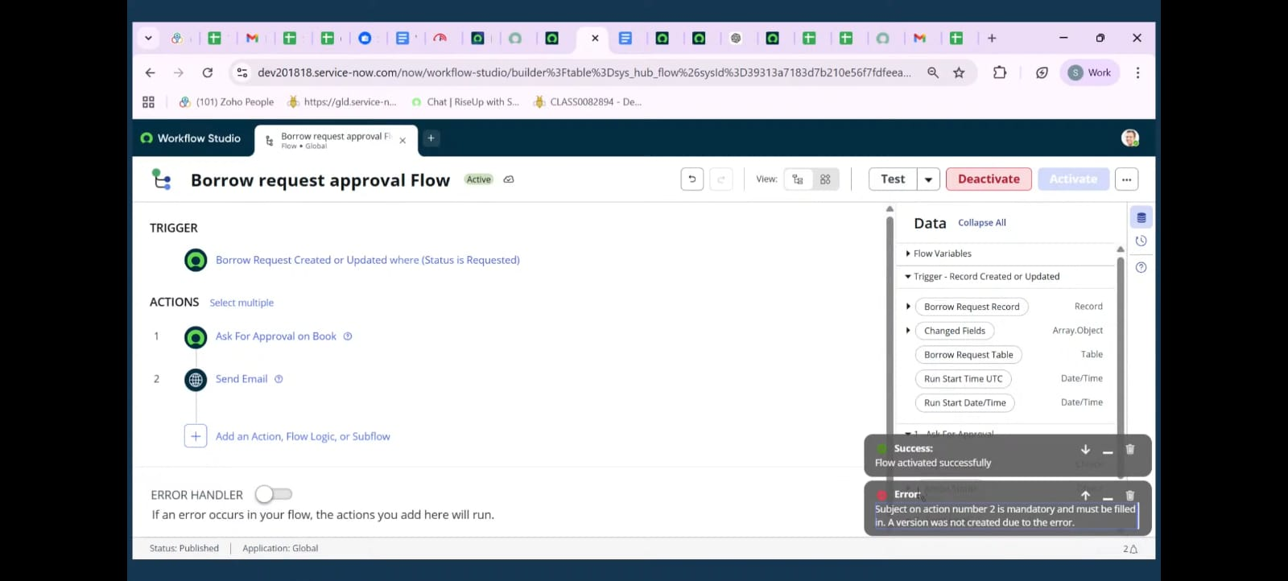
4.Workflow Automation
One of the most important parts of the system is the workflow automation that manages the book borrowing process. ServiceNow’s Flow Designer is used to automate actions when specific events occur in the system.
When a student submits a borrow request, the request enters the workflow and waits for librarian approval. Once the librarian reviews and approves the request, the workflow automatically updates the book status to “Issued.”
This automation eliminates the need for librarians to manually update book records, reducing errors and saving time.
Example Workflow Process
- A student submits a borrow request through the portal.
- The request is stored in the Borrow Request Table with the status Pending.
- The librarian reviews the request in the system.
- If the librarian approves the request, the Flow Designer workflow automatically updates the status to Approved.
- The book status in the Book Table changes from Available to Issued.
Example Scenario
A student named Anita requests the book “Operating Systems Concepts.” The librarian approves the request. Immediately after approval, the Flow Designer automatically updates the book’s status to Issued, ensuring that other students cannot request the same book until it is returned.

Business Rules and Notifications
To improve communication between the system and its users, Business Rules and Email Notifications are implemented. Business rules automatically execute specific actions when certain conditions are met.
In this project, a business rule triggers an email notification whenever a borrow request is approved or rejected. This ensures that students receive real-time updates about the status of their requests.
Notification Process
- The librarian approves or rejects a borrow request.
- A Business Rule detects the change in request status.
- The system automatically sends an email notification to the student.
- The student receives the message informing them about the request status.
Example Email Notification
If a student’s request is approved, they may receive an email like this:
Subject: Book Request Approved
Message:
"Your request for the book Database Management Systems has been approved. Please visit the library to collect the book."
If the request is rejected, the system sends a message explaining the reason, such as the book being unavailable.
Example Scenario
A student named Karthik requests the book “Computer Networks.” The librarian approves the request. Immediately after approval, the system sends Karthik an email confirming that the request has been approved and the book is ready for collection.
This automated notification system improves communication and reduces confusion for users.

Reference Qualifiers
Reference Qualifiers are implemented to improve the accuracy of data entry when students submit borrow requests. A reference qualifier filters the available options in a reference field based on specific conditions.
In this project, reference qualifiers ensure that students can only select books that are currently Available in the library.
This prevents students from requesting books that are already issued or unavailable.
Example Process
When a student opens the borrow request form, the Book selection field only displays books with the status Available. Books that are already borrowed or reserved are hidden from the list.
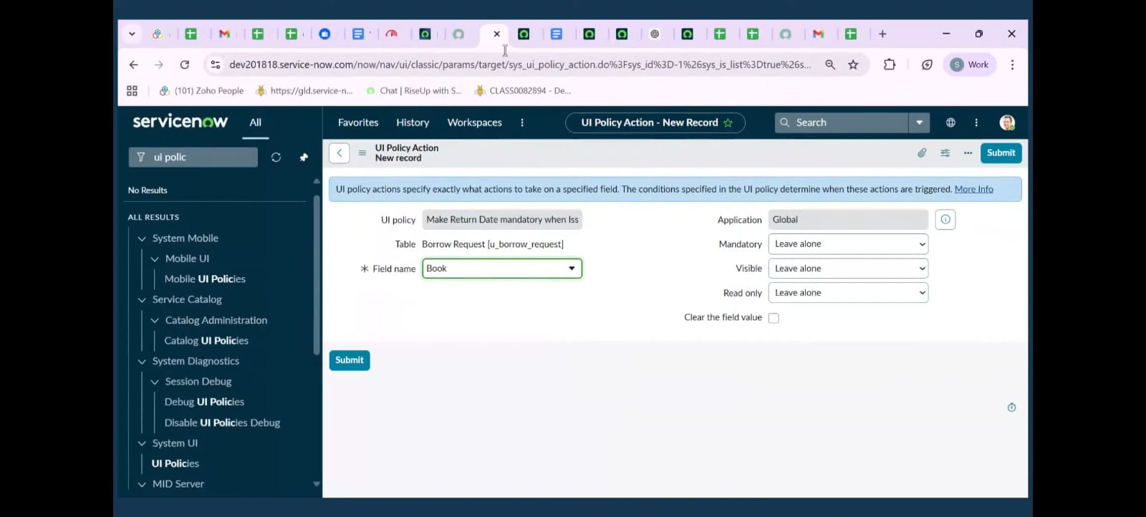


5. Project Design Phase
Introduction
The Project Design Phase focuses on defining the structure and user interface of the Smart Library Request Workflow in ServiceNow. During this phase, the system’s database tables, user interface behavior, and security controls are carefully designed to ensure smooth functionality and proper data management.
The design process includes creating structured tables to store book information, improving the user interface through UI policies, and implementing access control mechanisms to protect sensitive data. A well-designed system helps ensure that the application is easy to use, secure, and efficient.

Table Design
One of the most important tasks in the design phase is creating the Book Table, which stores all details related to the books available in the library. Proper table design ensures that the system can manage book information efficiently and maintain accurate records.
The Book Table includes several important fields that describe each book and its availability status.
Key Fields in the Book Table
- Title – The name of the book.
- Author – The person who wrote the book.
- ISBN – A unique identification number assigned to each book.
- Category – The subject or genre of the book.
- Status – Indicates whether the book is Available, Issued, or Lost.
Example Book Table Record
Book ID | Title | Author | ISBN | Status
B101 | Data Structures | Mark Allen | 978-1234567890 | Available
When a student borrows the book, the status automatically changes from “Available” to “Issued.”
Example Scenario
Suppose a book titled “Artificial Intelligence Basics” is added to the system. Initially, the status will be set to Available. If a student borrows the book, the system updates the status to Issued. If the book is lost or damaged, the librarian can change the status to Lost.
This table design allows the system to easily track book availability and maintain accurate records.
UI Enhancements
To improve usability and ensure proper data entry, UI Policies are implemented in the system. UI Policies control how fields behave on forms based on certain conditions.
In this project, UI policies are used to dynamically change form behavior depending on the status of a book. For example, the Return Date field becomes mandatory only when the book status is set to Issued.
This prevents users from entering unnecessary information and ensures that important details are recorded only when required.
Example UI Policy Logic
- If Book Status = Issued, then Return Date = Mandatory
- If Book Status ≠ Issued, then Return Date = Not Mandatory
Example Scenario
A librarian issues a book to a student. When the librarian selects the book status as Issued, the system automatically requires the Return Date field to be filled before saving the record.
If the book status is Available, the Return Date field will not be required.
Benefits of UI Enhancements
- Improves user experience by simplifying forms
- Prevents incomplete or incorrect data entry
- Ensures required information is collected at the right time
- Makes the application easier to use for librarians
6. Project Documentation Phase
Introduction
The Project Documentation Phase is an important part of the Smart Library Request Workflow in ServiceNow project. Documentation helps explain how the system is designed, developed, and implemented so that other developers, administrators, or users can understand and reproduce the system if needed.
Proper documentation ensures that the project is easy to maintain, update, and deploy in different environments. In this phase, the project includes two main documentation components: the Technical Blueprint and the Setup Manual.

Technical Blueprint
The Technical Blueprint provides a detailed description of the internal structure of the system. It explains how the application works, including the tables used, variables involved, workflows implemented, and how different components interact with each other.
This blueprint helps developers and system administrators understand the logic and design of the Smart Library Request Workflow.
Variables and Data Fields
The system includes several variables and fields that are used to manage borrowing requests and track book transactions.
Some important variables include:
- Borrow Date – The date when a student borrows a book.
- Return Date – The expected date when the book should be returned to the library.
- Book Status – Indicates whether the book is Available, Issued, or Lost.
- Request Status – Shows the status of a borrow request (Pending, Approved, Rejected).
Example
When a student submits a borrow request, the system records the Borrow Date and sets the Request Status to Pending. Once the librarian approves the request, the Book Status changes to Issued and the Return Date is recorded.

Fulfillment Task Use Cases
The system also includes fulfillment tasks that help librarians manage requests efficiently. A fulfillment task is automatically generated when a borrow request requires librarian action.
These tasks are assigned to the Librarian Group, allowing library staff to review and process requests in an organized manner.
Example Scenario
- A student submits a request for the book “Database Management Systems.”
- The system creates a Fulfillment Task assigned to the librarian group.
- A librarian reviews the request and approves it.
- The system updates the request status and book status accordingly.
This process ensures that requests are handled systematically and that librarians can easily track pending tasks.

Setup Manual
The Setup Manual provides a clear and step-by-step guide for recreating the Smart Library Request Workflow in a ServiceNow Personal Developer Instance (PDI). This guide is especially useful for developers or students who want to implement the same solution in their own environment.
The manual explains the order of operations and includes instructions for configuring tables, roles, workflows, and automation features.
Step-by-Step Setup Process
Step 1: Create Roles
- Create two roles in ServiceNow:
  - Student
  - Librarian
These roles will define user permissions and access levels.

Step 2: Create Tables
Create two custom tables in the ServiceNow database:
- u_book – Stores book details such as title, author, ISBN, and status.
- u_borrow_request – Stores borrow request details including student name, book reference, and request status.

Step 3: Add Fields
Add necessary fields to the tables.
Example fields for u_book table:
- Title
- Author
- ISBN
- Category
- Status
Example fields for u_borrow_request table:
- Student Name
- Book Reference
- Borrow Date
- Return Date
- Request Status

Step 4: Configure Forms
Design forms for both tables so that users can easily view and enter information.
For example:
- Students use a form to submit borrow requests.
- Librarians use a form to update book details and request statuses.

Step 5: Create Workflow Using Flow Designer
Develop a flow that triggers when a borrow request is approved.
The workflow should:
- Update the book status to Issued
- Send a notification to the student

Step 6: Add Business Rules and Notifications
Create business rules that automatically send email notifications when a request is approved or rejected.

Step 7: Apply Reference Qualifiers
Configure reference qualifiers so that students can only see books with the status Available when creating a request.

Step 8: Test the System
Perform testing to ensure that:
- Borrow requests are submitted correctly
- Librarian approvals work properly
- Book status updates automatically
- Notifications are sent to students

Use of Screenshots
The setup manual also includes screenshots of key configuration steps, such as:
- Table creation in ServiceNow
- Form design
- Flow Designer configuration
- Notification setup
Screenshots help users follow the instructions more easily and understand the system setup visually.
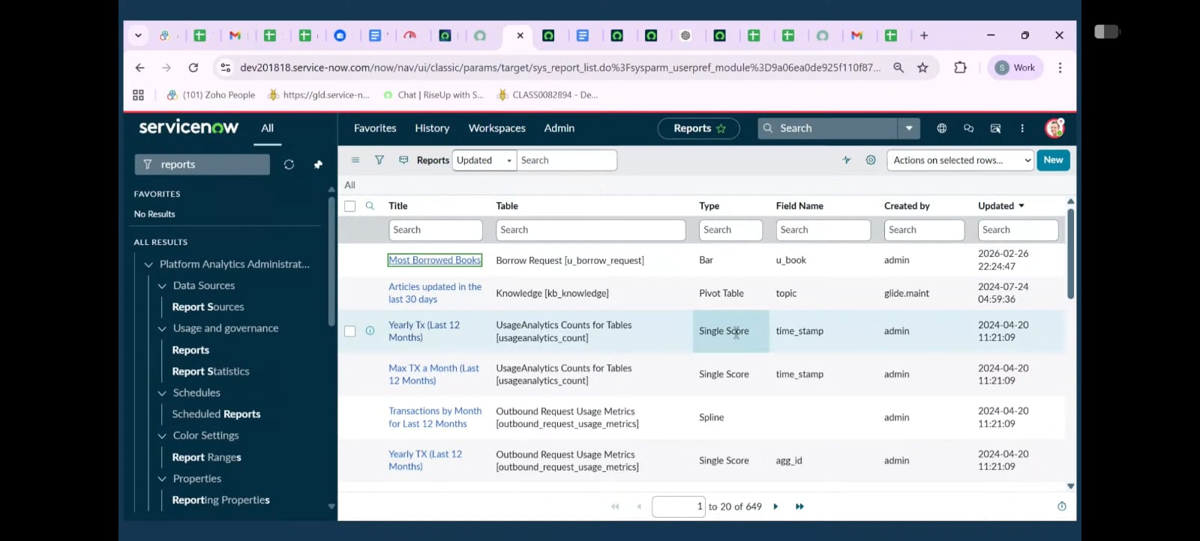
7. Project Demonstration Phase
Introduction
The Project Demonstration Phase is used to present how the Smart Library Request Workflow in ServiceNow works in a real-time environment. This phase shows the complete working process of the system from the user perspective. It helps stakeholders, instructors, and evaluators understand how the system functions and how it improves the library management process.
The demonstration mainly includes three parts: Portal Walkthrough, Workflow Execution, and Reporting Dashboard. These components display the system’s features and how different users interact with the platform.

Portal Walkthrough
The Service Portal provides a user-friendly interface where students can interact with the library system. Through the portal, students can search for books, check availability, and submit borrow requests.
During the demonstration, the presenter logs into the ServiceNow Service Portal using a student account and shows how the system can be used to request a book.
Demonstration Steps
- The student logs into the ServiceNow Service Portal.
- The student navigates to the Library Book Request catalog item.
- The student searches for a book from the available list.
- The student fills out the request form and submits it.
Example Scenario
A student named Rahul logs into the portal and searches for the book “Operating System Concepts.” The system shows that the book is available. Rahul fills in the borrow request form and submits the request.
Once submitted, the system records the request and sets the request status to Requested.
This part of the demonstration highlights how easy it is for students to interact with the system.

Workflow Execution
The next part of the demonstration focuses on the workflow execution process. This shows how the system processes a borrow request from the initial request stage to the final return stage.
The workflow automation developed using ServiceNow Flow Designer handles the request and updates the system status automatically.
Workflow Stages
The system follows several stages in the borrowing process:
- Requested – The student submits a borrow request.
- Approved – The librarian reviews and approves the request.
- Issued – The book is issued to the student and its status is updated.
- Returned – The student returns the book to the library.
Example Workflow Scenario
- Rahul submits a request for the book “Computer Networks.”
- The librarian receives the request in the system dashboard.
- The librarian reviews the request and approves it.
- The system automatically updates the book status to Issued.
- When Rahul returns the book to the library, the librarian updates the system status to Returned.
- The book status is then changed back to Available.
This demonstration shows the complete lifecycle of a borrow request and highlights how automation simplifies the process.

